RESOLUTION DESIGNATING
STETSON RENEWABLES HOLDINGS, LLC
REINVESTMENT ZONE

WHEREAS, the Board of Trustees of the Nursery Independent School District (“District”) seeks to promote the development or redevelopment of a certain contiguous geographic area within its jurisdiction by the creation of a reinvestment zone;

WHEREAS, the District is authorized by the Property Redevelopment and Tax Abatement Act, as amended (Texas Tax Code § 312.0025), for the purpose of authorizing an Agreement for Limitation on Appraised Value of Property for School District Maintenance and Operations Taxes, as authorized by Chapter 313 of the Texas Tax Code; and,

WHEREAS, pursuant to Texas Tax Code § 312.201(d), a newspaper notice was published and written notice delivered to the respective taxing entities within this jurisdiction at least seven (7) days prior to a public hearing on the designation of the reinvestment zone; and

WHEREAS, the Board of Trustees at such public hearing invited any interested person to appear and speak for or against the creation of the reinvestment zone; and,

WHEREAS, the Board of Trustees considered information provided by proponents and opponents of the creation of the reinvestment if any, and in accordance with previously adopted Criteria and Guidelines,

WHEREAS, the Board of Trustees considered the creation of a reinvestment zone related to a tax limitation agreement submitted by Stetson Renewables Holdings, LLC for property within the District’s boundaries and depicted in the attached Exhibits A and B;

BE IT RESOLVED BY THE BOARD OF TRUSTEES OF THE NURSERY INDEPENDENT SCHOOL DISTRICT:

SECTION 1. That the facts and recitations contained in the preamble of this Resolution are hereby found and declared to be true and correct.

SECTION 2. That the Board of Trustees of the Nursery Independent School District, after conducting such hearing and having heard such evidence and testimony, has made the following findings and determinations based on the evidence and testimony presented to it:

- That the public hearing on the adoption of the Stetson Renewables Holdings, LLC Reinvestment Zone has been properly called, held and conducted, and that notices of such hearing have been published as required by law and mailed to the respective presiding officers of the governing bodies of each taxing unit which includes within its boundaries real property that is to be included in the proposed reinvestment zone; and,
- That the boundaries of the Stetson Renewables Holdings, LLC Reinvestment Zone are within the boundaries of the District and by the adoption of this Resolution is declared and certified to be the area described in the attached Exhibits A and B; and,
- That creation of the Stetson Renewables Holdings, LLC Reinvestment Zone with boundaries as described in Exhibits A and B will result in economic benefits to the District and that the improvements sought are feasible and practical; and,
- The Stetson Renewables Holdings, LLC Reinvestment Zone described in Exhibits A and B meets the criteria set forth in Texas Tax Code § 312.0025 for the creation of a reinvestment zone as set forth in the Property Redevelopment and Tax Abatement Act, as amended, in that it is reasonably likely that the designation will contribute to the retention or expansion of primary employment, and/or will attract investment in the zone that will be a benefit to the property, and would contribute to economic development within the District.

SECTION 3. That pursuant to the Property Redevelopment and Tax Abatement Act, as amended, the District, hereby creates a reinvestment zone under the provisions of Tex. Tax Code § 312.0025, encompassing the area described by the descriptions in Exhibits A and B, and such reinvestment zone is hereby designated and shall hereafter be referred to as the Stetson Renewables Holdings, LLC Reinvestment Zone.

SECTION 4. That the Stetson Renewables Holdings, LLC Reinvestment Zone shall take immediate effect upon adoption by the Board of Trustees and shall remain designated as a commercial-industrial reinvestment zone for a period of five (5) years from such date of such designation.

SECTION 5. That if any section, paragraph, clause, or provision of this Resolution shall for any reason be held to be invalid or unenforceable, the invalidity or unenforceability of such section, paragraph, clause, or provision shall not affect any of the remaining provisions of this Resolution.

SECTION 6. That it is hereby found, determined and declared that a sufficient notice of the date, hour, place, and subject of the meeting of the District Board of Trustees, at which this Resolution was adopted, was posted at a place convenient and readily accessible at all times, as required by the Texas Open Government Act, Texas Government Code, Chapter 551, as amended; and that a public hearing was held prior to the designation of such reinvestment zone, and that proper notice of the hearing was published in newspapers of general circulation in Victoria County, and furthermore, such notice was, in fact, delivered to the presiding officer of any affected taxing entity as prescribed by the Property Redevelopment and Tax Abatement Act.

PASSED, APPROVED, AND ADOPTED on this 28th day of November, 2022.

Nursery Independent School District

By: ______________________________
President, Board of Trustees

Attest:

By: ______________________________
Secretary, Board of Trustees

CERTIFICATION

I hereby certify that the foregoing resolution was presented to the Board of Trustees of the Nursery Independent School District during a special meeting on November 28, 2022. A quorum of the Board of Trustees being then present, it was then duly moved and seconded that the resolution be adopted according to the following votes,

Ayes: ______________
Nays: ______________
Abstentions: ______________

To certify which, witness my hand this 28th day of November, 2022.

By: __________________________________
President, Board of Trustees

EXHIBIT A
Property Included in the Reinvestment Zone

The Reinvestment Zone includes all the area in the Victoria County Appraisal District tax parcels listed below that lie within the boundaries of Nursery ISD. Maps of the Reinvestment Zone is attached as Exhibit B. In the event of a discrepancy between Exhibit A and the attached maps on Exhibit B, Exhibit A shall control.

The total area of the Reinvestment Zone is approximately 5,687.51 acres.

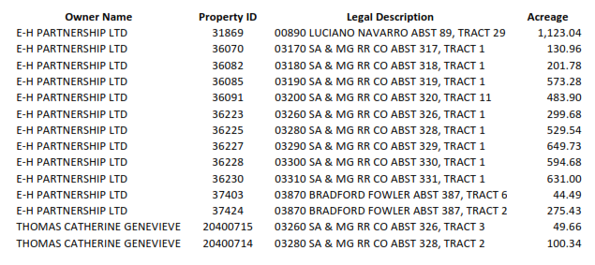

EXHIBIT B
MAP OF PROPOSED STETSON RENEWABLES HOLDINGS, LLC REINVESTMENT ZONE

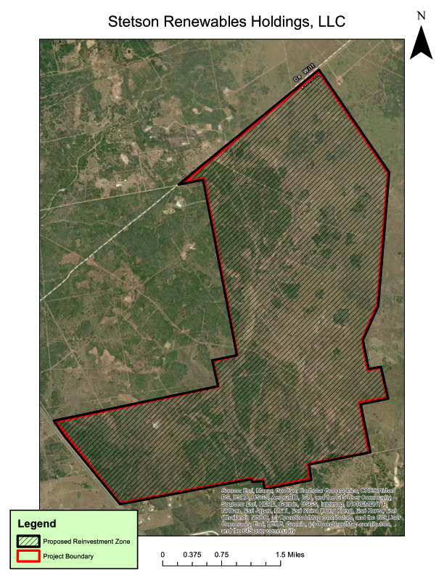
The boundaries of the Stetson Renewables Holdings, LLC Reinvestment Zone will be entirely within Nursery ISD’s boundaries and more particularly described in the following maps:

